# **Name: Abdurrahman Qureshi**

# **Roll No: 242466**

Practical No: 7

Date Of Performance: 04/09/2025

Aim: To understand and demonstrate the use of AWS DynamoDB (NoSQL database)

1. What is NO SQL, key value Databases?
2. Create a Table in DynamoDB, add items to the table (minimum 10 items), Query the table

ANS.1:

**NoSQL** ("Not Only SQL") is a category of databases designed for scalability and flexibility beyond traditional SQL. They are often schema-less, allowing for evolving data structures.

A **Key-Value Database** is a simple NoSQL type where every data item is stored as a key (a unique identifier) paired with its value (the data itself). This model enables incredibly fast reads and writes, as data is accessed directly via its key, making it ideal for simple, high-speed operations like caching, session storage, and user profiles. DynamoDB is a prime example.

ANS.2:

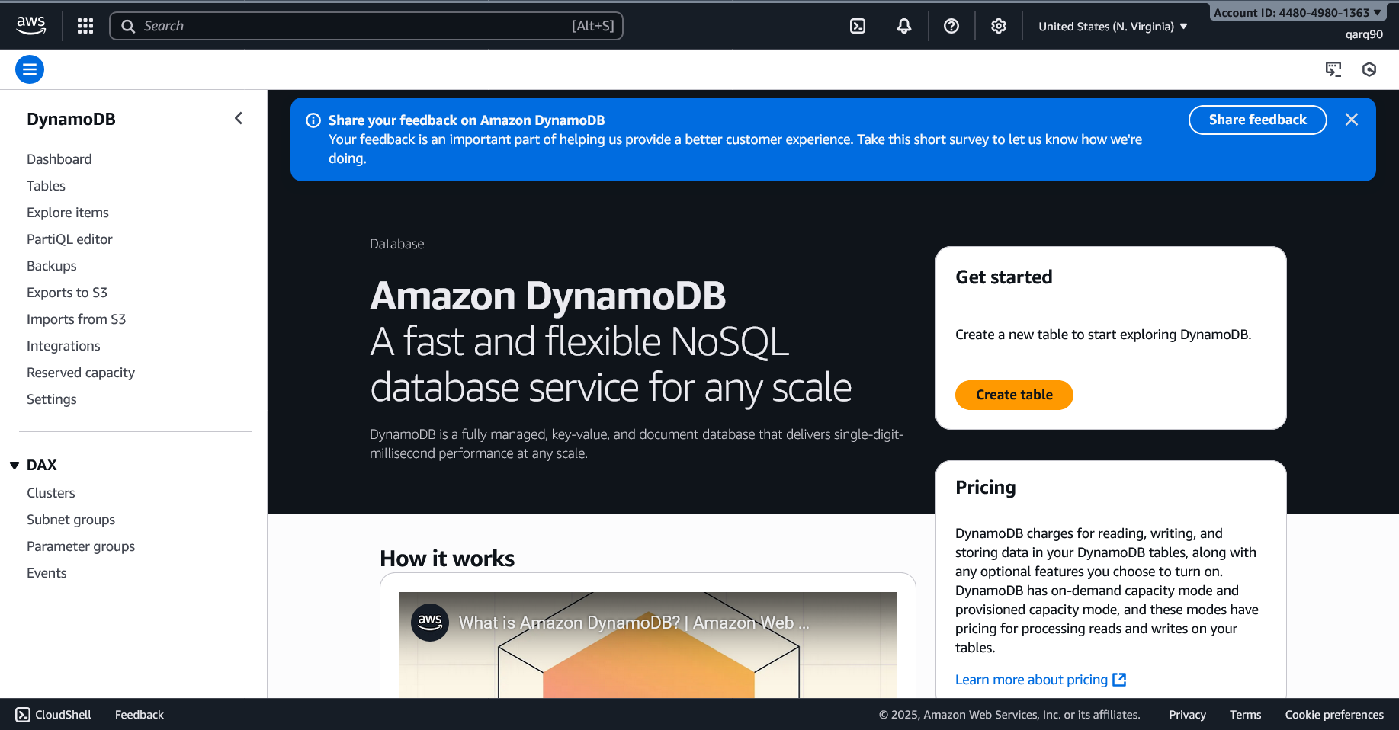

Dynamo DB Page

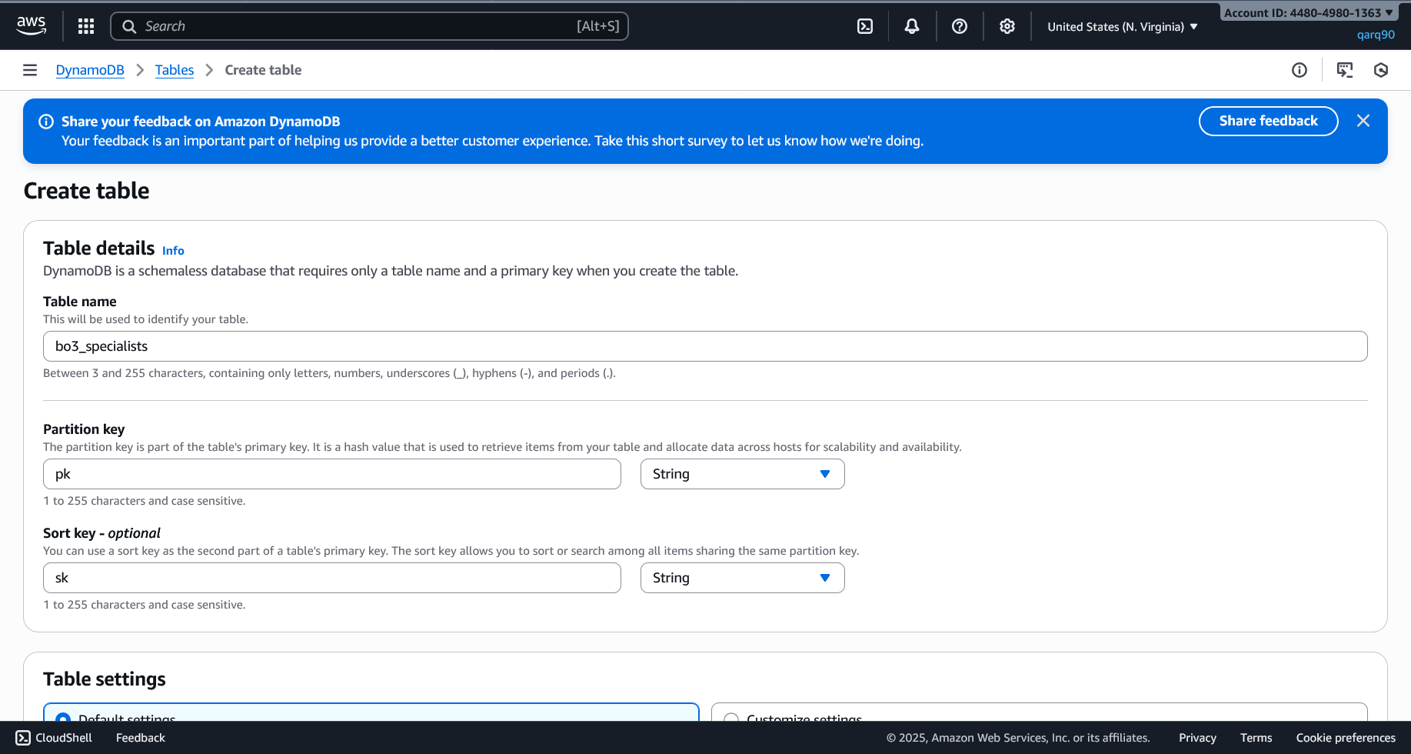

Creating a new table “bo3_specialists”

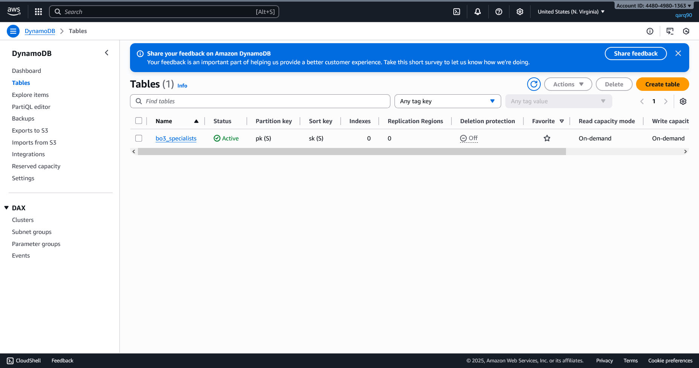

Table Created

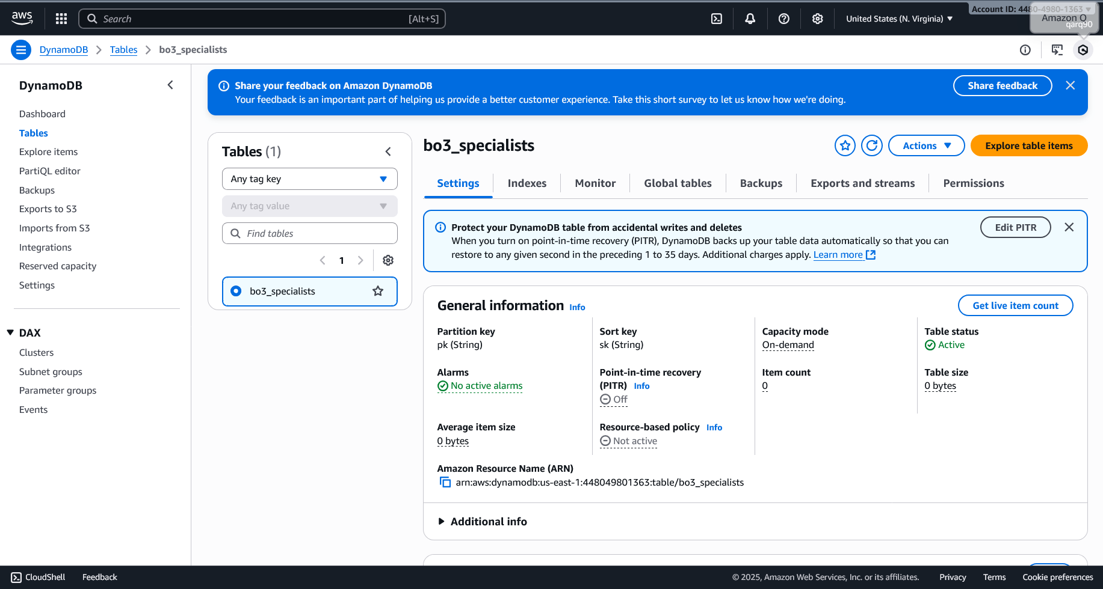

Table Details

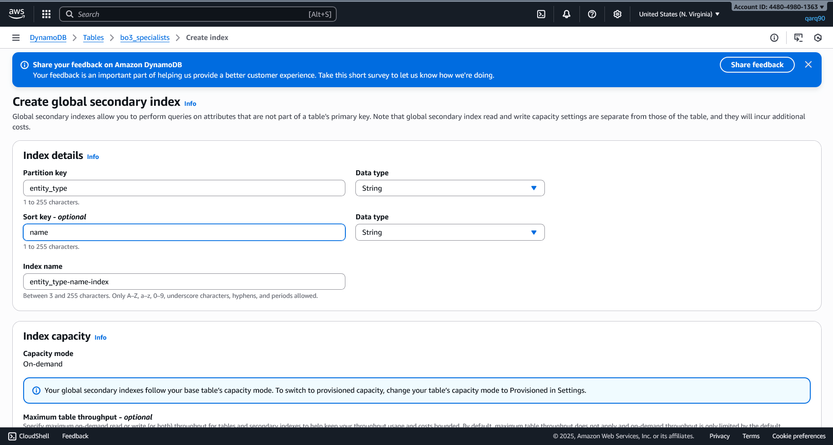

Creating Partition, Sort Key and Index name

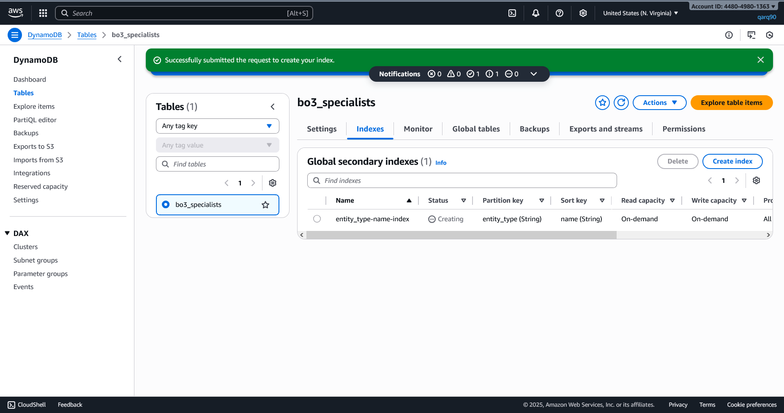

Created Partition, Sort Key and Index name

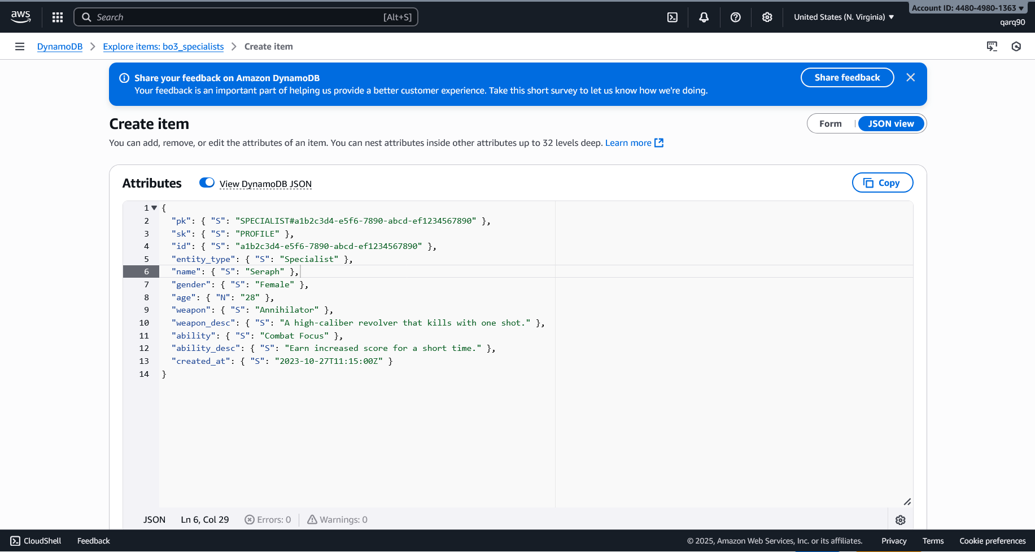

Adding “Seraph”to the Database

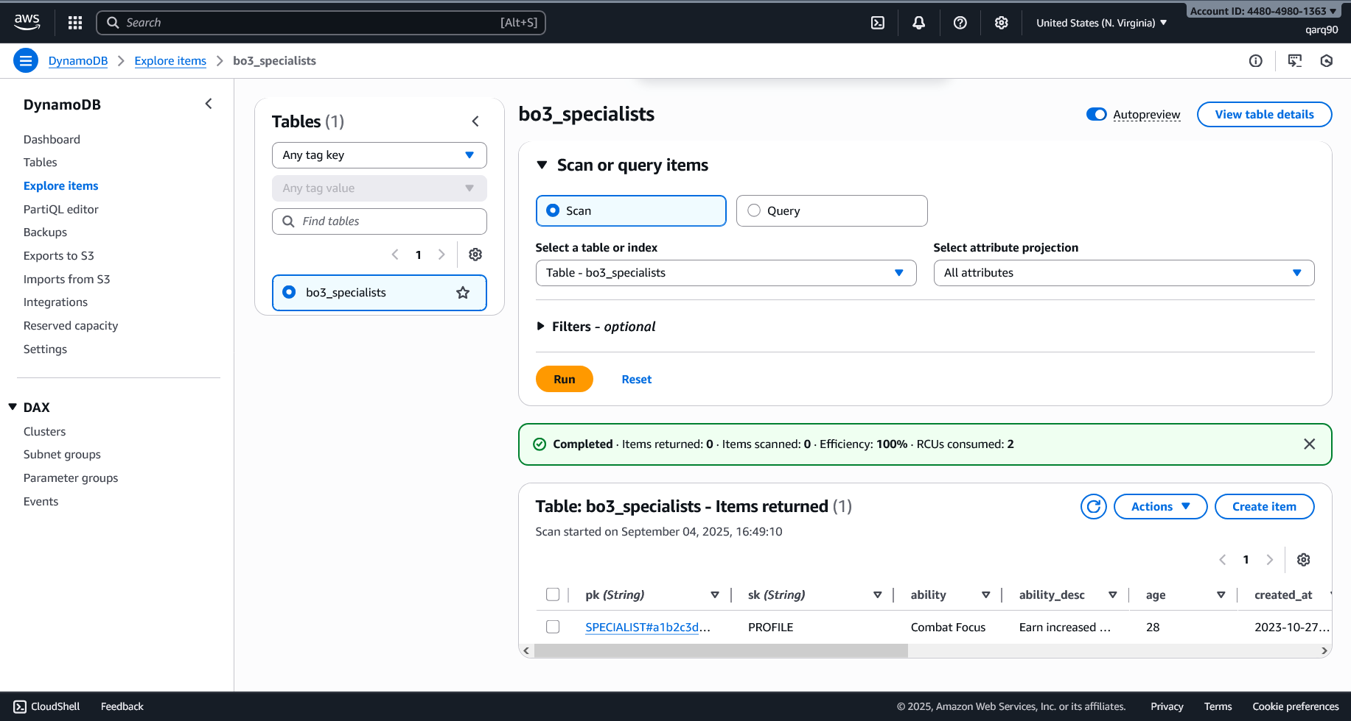

Added“Seraph”to the Database

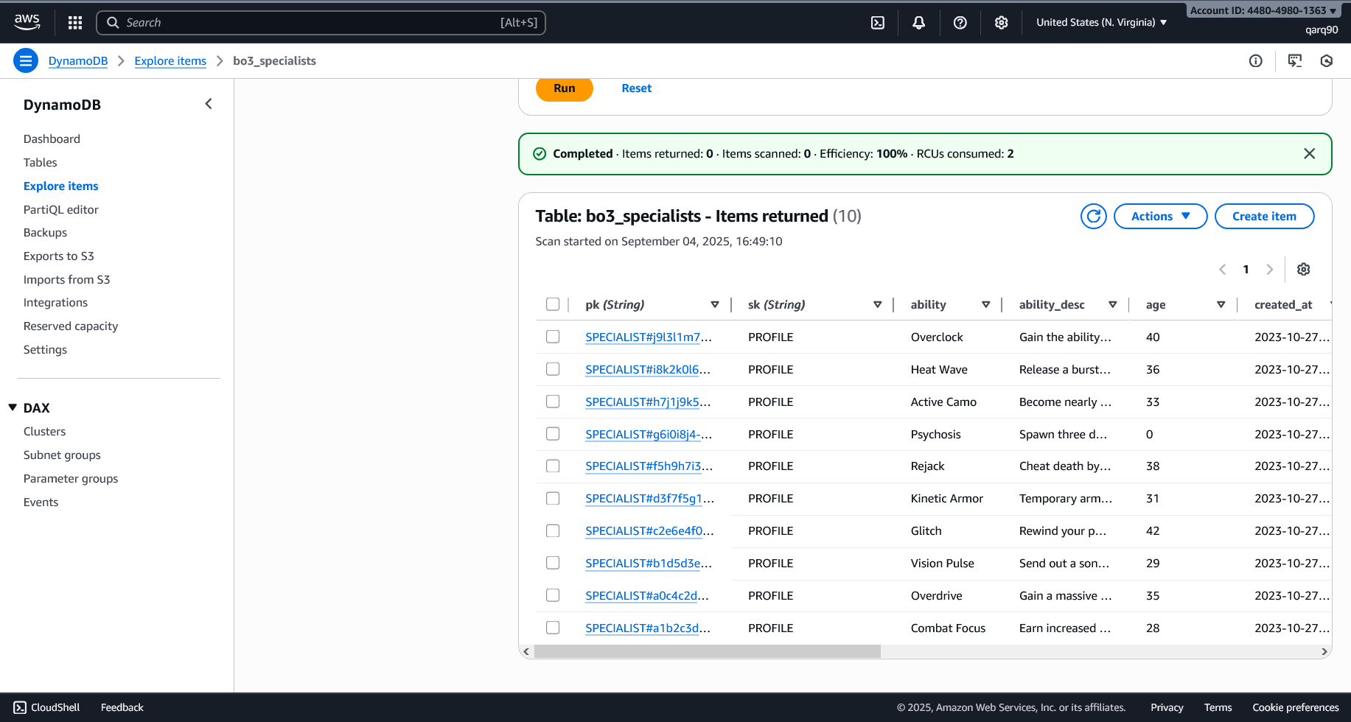

Added more specialists

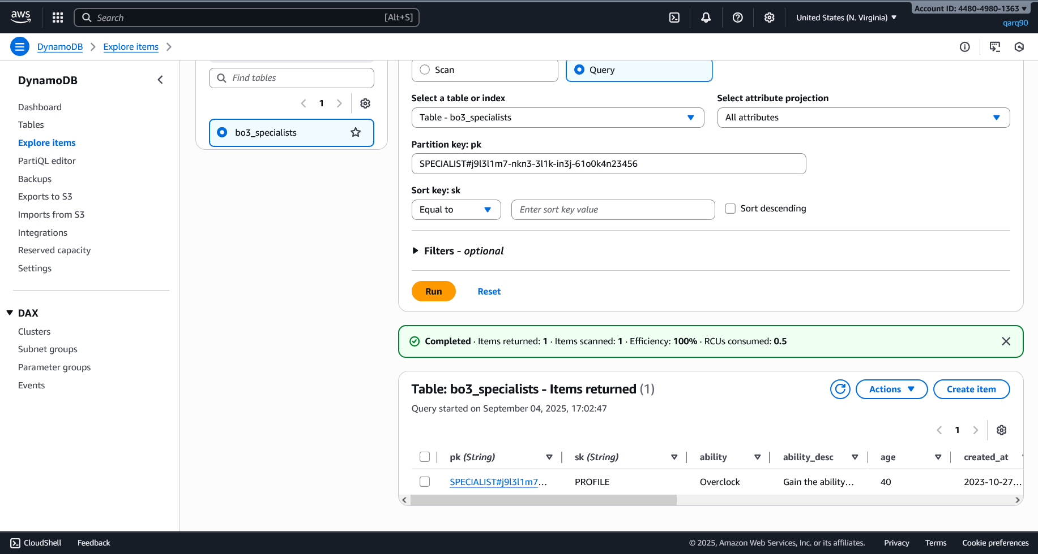

Query via a Partition Key

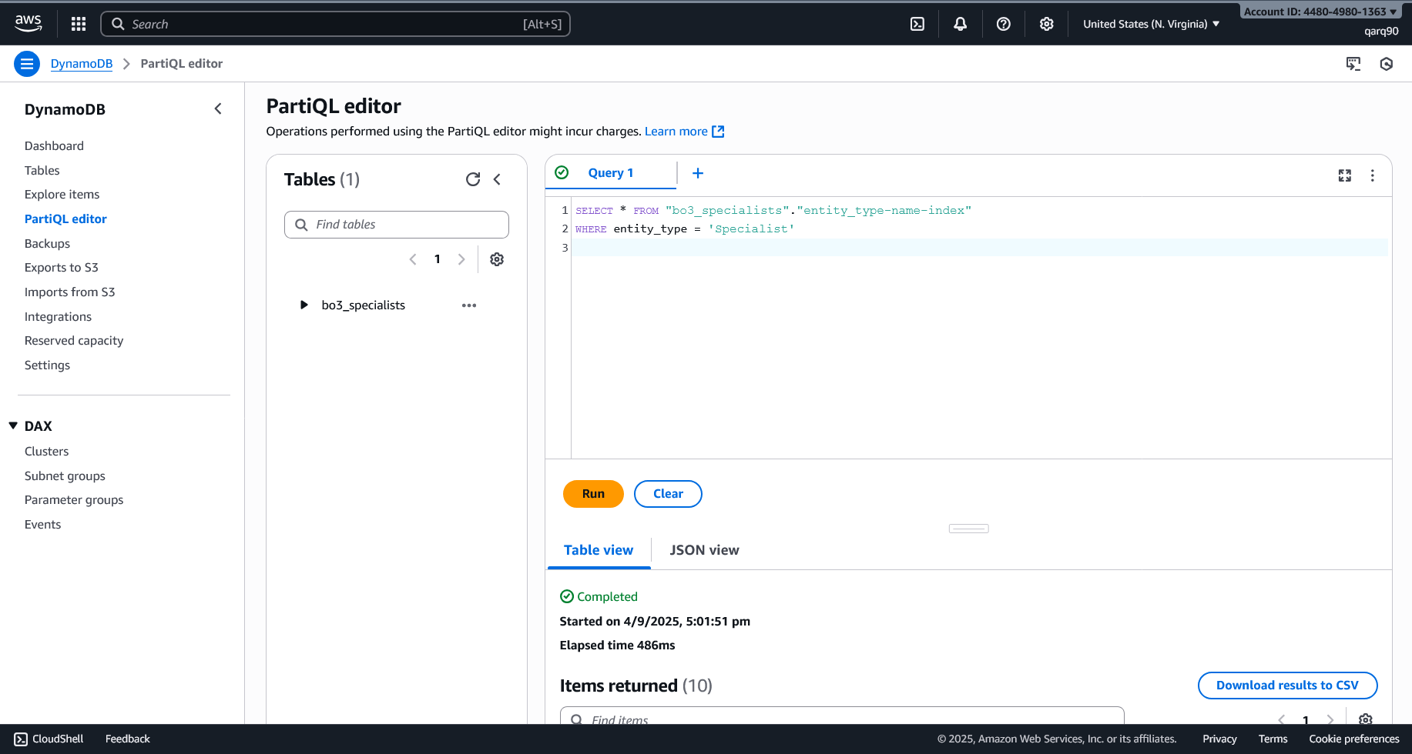

Querying via PartiQL Editor

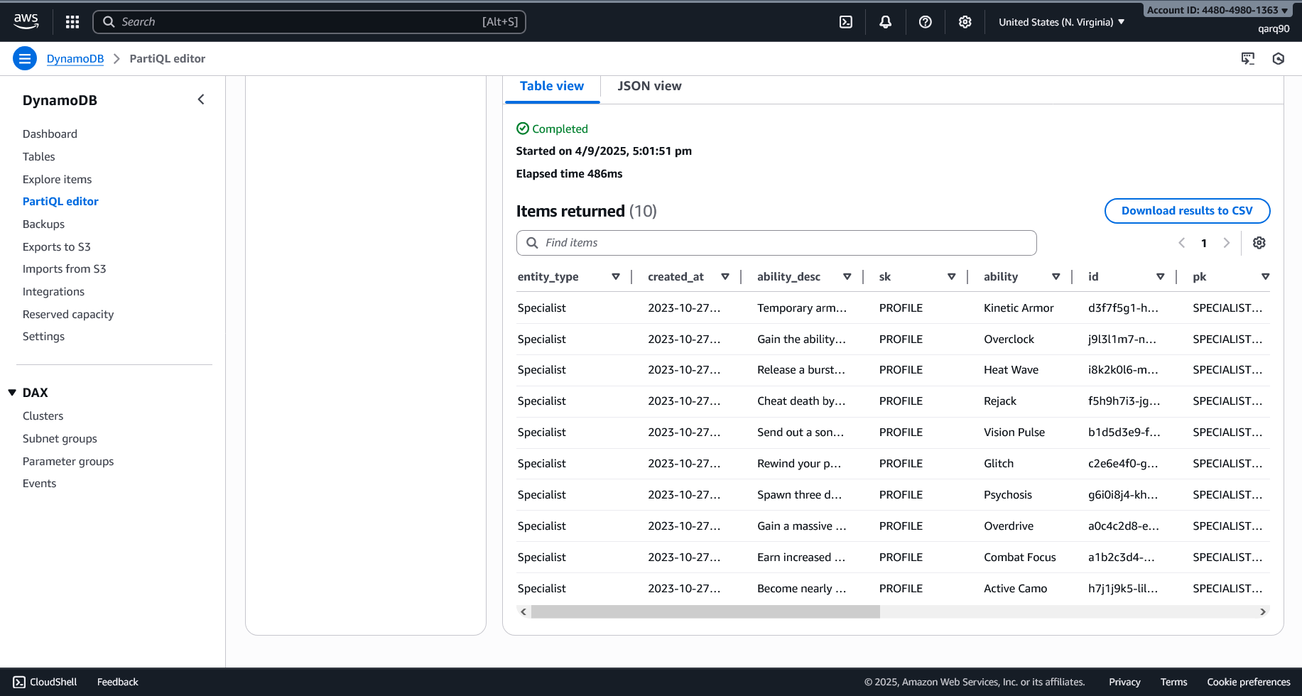

Query Result